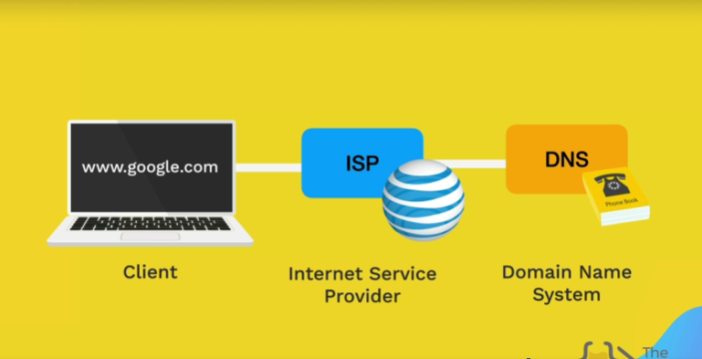
WEBSITE WORKS

How does website work?

1. User Action
- Typing the URL: The process begins when a user types a website URL (Uniform Resource Locator) into their web browser's address bar and presses Enter.
- DNS Lookup: The browser contacts the Domain Name System (DNS) to resolve the human-readable URL (like www.example.com) into an IP address (like 192.0.2.1), which identifies the server where the website is hosted.
2. Establishing a Connection
- TCP/IP Connection: Once the IP address is known, the browser initiates a connection to the server using the Transmission Control Protocol (TCP). This involves a handshake process to establish a reliable connection.
- SSL/TLS Handshake (if HTTPS): If the URL starts with HTTPS, an SSL/TLS handshake is performed to establish a secure encrypted connection between the browser and the server.
3. Sending the Request
- HTTP Request: The browser sends an HTTP request to the server. This request includes the method (GET, POST, etc.), the URL, headers (like User-Agent, Accept-Language), and sometimes a body (for POST requests).
4. Server Processing
- Server Receives Request: The server receives the request and processes it. This may involve:
  - Routing: Determining which resource or endpoint should handle the request.
  - Backend Processing: Executing server-side scripts, querying databases, performing business logic, etc.
- Database Interaction: If the request requires data from a database, the server queries the database and retrieves the necessary data.
- Generating the Response: The server generates an HTTP response, which includes a status code (200 for success, 404 for not found, etc.), headers, and the response body (HTML, JSON, XML, etc.).
5. Sending the Response
- HTTP Response: The server sends the HTTP response back to the browser over the established TCP connection.
6. Browser Rendering
- Parsing HTML: The browser receives the HTML content and begins parsing it. It constructs the DOM (Document Object Model) tree.
- Loading Resources: As the browser parses the HTML, it encounters references to other resources like CSS files, JavaScript files, images, fonts, etc. The browser makes additional HTTP requests to fetch these resources.
- Applying CSS: The browser parses the CSS files and applies the styles to the elements in the DOM tree.
- Executing JavaScript: The browser executes any JavaScript code found in the HTML or in external files. This can modify the DOM, handle user interactions, make additional requests (AJAX), etc.
- Rendering the Page: The browser renders the content on the screen, creating the visual representation of the website.
7. User Interaction
- Interactivity: The user can now interact with the website by clicking links, filling out forms, submitting data, etc. These interactions may trigger additional requests to the server, continuing the cycle.
Real-World Example
When you type "www.example.com" in your browser:
- DNS Lookup: The browser resolves "www.example.com" to an IP address.
- TCP Connection: The browser establishes a connection to the server at that IP address.
- HTTP Request: The browser sends an HTTP GET request to the server for the homepage.
- Server Response: The server processes the request, possibly querying a database, and sends back an HTML document.
- Rendering: The browser parses the HTML, loads CSS and JavaScript, and displays the homepage.
- Interaction: The user clicks a link to another page, repeating the process.
This is a simplified overview, and many optimizations and additional steps (like caching, load balancing, etc.) can be involved in a real-world scenario.
CN
1.Switch, Router and hub which layer works and differentiate it?
Hub works in physical layer
Switch works in data link layer
Router works in network layer
Hub-> it broad cast data to all interconnected devices it doesn’t filter ex: office network
Switch -> it forward data to the intended devices based on mac address ex: network switch
Router -> it routes the data using IP address
2.Give examples of some protocols?
HTTP -> Transferring the webpages ex: loading website.
HTTPS -> secure http by encrypting data. Ex: online banking app.
FTP -> Transferring files through internet Ex: uploading files to server.
ICMP -> It provides error message. and provide how to resolve the problem (manuals) network diagnostics. Ex: pinging a server.
DHCP -> IT assigns an IP address dynamically to a device on a network ex: connecting Wi-Fi
SMTP -> send and receive mail Ex: send a mail from the client to mail server.
POP3 -> Doesn’t store email in server
3. ICMP uses a ping command. This command diagnostics the connecting issues by sending echo request and it measures a response time.
Multicasting and broadcasting
Multicasting: send a data to specific group of devices or host(client) ex: send video stream to group of devices/people
Broadcasting: send data to all the devices on the network ex: chat application (broadcast channel) other example DHCP server assign the IP address to all the devices that relate to the same network.
4.Why TCP is connection oriented?
Connection orientation means that the communicating devices should establish a connection before transmitting data and should close the connection after transmitting the data.
TCP connection is a bytestream, and UDP is a message stream
TCP -> uploaded videos of YouTube
UDP -> Video call, online gaming, skype, zoom meeting

5.If UDP is not reliable, why do we use it?
UDP (User Datagram Protocol) is used in situations where speed is more critical than reliability.
UDP is used in applications requiring low latency and minimal overhead, such as video streaming (e.g., YouTube Live), online gaming (e.g., Fortnite), VoIP (e.g., Skype), DNS (e.g., domain name lookups), and live broadcasts (e.g., Twitch).

Question: Why might an application choose UDP over TCP?
Answer: An application might choose UDP over TCP for its lower latency, support for broadcast and multicast, simplicity, reduced connection overhead, and the ability to handle packet management independently.

Question: What are some real-time applications that use UDP and why?
Answer: Real-time applications like video streaming, online gaming, and VoIP use UDP because it offers faster data transmission, which is crucial for maintaining responsiveness and timely delivery.

Question: How does UDP handle error checking and correction?
Answer: UDP itself does not handle error checking and correction. These responsibilities are left to the application layer, allowing applications to implement their own mechanisms suited to their specific needs.

Question: Can you name a protocol that relies on UDP and explain its purpose?
Answer: The Domain Name System (DNS) relies on UDP for quick query and response transactions. Speed is essential for DNS lookups, and the occasional packet loss can be tolerated by simply re-sending the request.

Question: What is the primary advantage of UDP in online gaming?
Answer: The primary advantage of UDP in online gaming is its low latency, which ensures real-time communication between players, making the gaming experience more responsive.

Question: How does UDP support broadcasting and multicasting, and why is this useful?
Answer: UDP supports broadcasting and multicasting by allowing a single packet to be sent to multiple recipients. This is useful for network services like DHCP and streaming media to multiple users simultaneously.

Question: In what scenarios might the overhead of TCP be unnecessary?
Answer: The overhead of TCP might be unnecessary in scenarios involving short message exchanges, such as simple queries, where the connection setup and teardown overhead of TCP would outweigh the benefits of its reliability.

Question: Why is UDP considered more efficient than TCP?
Answer: UDP is considered more efficient than TCP due to its simpler header structure and lack of connection management, resulting in less processing and transmission overhead.

Question: How does UDP handle retransmission of lost packets?
Answer: UDP does not handle retransmission of lost packets. It is up to the application to implement any necessary retransmission mechanisms.

Question: What makes UDP suitable for live broadcasting?
Answer: UDP is suitable for live broadcasting because it allows data to be transmitted quickly with minimal delay, which is crucial for live events where timely delivery is more important than perfect accuracy.
Broadcast and Multicast
UDP supports broadcasting and multicasting, where a single packet is sent to multiple recipients. This is beneficial for applications like:
- Network discovery protocols (e.g., DHCP)
- Streaming media to multiple users simultaneously

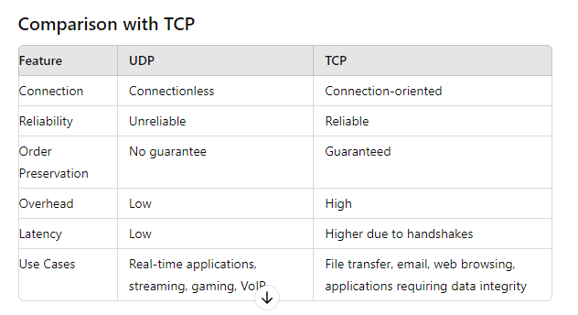

How does internet work
1. Basic Components
a. Devices
- Computers, Smartphones, Tablets, etc.: These are the end-user devices that access the internet.
b. Networks
- Local Area Networks (LANs): Smaller networks within homes or businesses.
- Wide Area Networks (WANs): Larger networks that span cities, countries, or even continents.
c. Routers and Switches
- Routers: Direct data packets between networks.
- Switches: Connect devices within a network and direct traffic based on MAC addresses.
d. Servers
- Web Servers: Host websites and respond to HTTP requests.
- Email Servers: Manage and store email communications.
- DNS Servers: Translate domain names into IP addresses.
2. Internet Protocols
a. IP Addresses
- IPv4 and IPv6: Unique addresses assigned to each device on the network, allowing them to be located and identified.
b. TCP/IP (Transmission Control Protocol/Internet Protocol)
- TCP: Ensures data packets are transmitted reliably and in order.
- IP: Routes the packets from source to destination.
c. HTTP/HTTPS (Hyper Text Transfer Protocol/Secure)
- HTTP: Protocol for transferring web pages.
- HTTPS: Secure version of HTTP, encrypting data between client and server.
d. DNS (Domain Name System)
- DNS: Converts human-readable domain names (e.g., www.example.com) into IP addresses (e.g., 192.0.2.1).
3. Data Transmission
a. Data Packets
- Packets: Data is broken into small packets for transmission. Each packet contains a portion of the data, along with the destination IP address and sequencing information.
b. Routing
- Routers: Direct packets across the internet using the most efficient path. This process involves multiple hops between routers.
c. Switching
- Switches: Within a local network, switches direct packets based on MAC addresses.
4. Connecting to the Internet
a. ISP (Internet Service Provider)
- ISP: Provides the connection to the internet for end-users. Examples include AT&T, Comcast, and Verizon.
b. Modems and Routers
- Modem: Connects to the ISP’s network, converting digital data to analog signals and vice versa.
- Router: Distributes the internet connection to multiple devices within a local network.
5. The Journey of a Data Packet
- User Request: A user types a URL into a web browser.
- DNS Lookup: The browser contacts a DNS server to resolve the domain name to an IP address.
- Establishing Connection: The browser establishes a connection to the server using TCP/IP.
- Data Transfer: The browser sends an HTTP request to the server for the web page.
- Server Response: The server processes the request and sends back the requested web page as a series of data packets.
- Routing: The packets travel through multiple routers and networks to reach the user’s device.
- Reassembly: The browser reassembles the packets into the complete web page and displays it to the user.
6. Internet Infrastructure
a. Backbone
- Internet Backbone: High-capacity networks and cables that form the core of the internet, often owned by large telecommunications companies.
b. Data Centers
- Data Centers: Facilities housing large numbers of servers that store and manage data.
c. Undersea Cables
- Undersea Cables: Fiber optic cables laid on the ocean floor, connecting different continents and enabling global communication.
7. Security
a. Firewalls
- Firewalls: Protect networks by filtering incoming and outgoing traffic based on security rules.
b. Encryption
- Encryption: Protects data by converting it into a secure format that can only be read by authorized parties.
Real-World Example: Accessing a Website
- DNS Resolution: You type “www.example.com” into your browser. The browser queries a DNS server to get the IP address for the domain.
- TCP Connection: The browser establishes a TCP connection with the server at the resolved IP address.
- HTTP Request: The browser sends an HTTP GET request to the server for the homepage.
- Server Processing: The server processes the request, potentially querying databases or executing server-side code.
- HTTP Response: The server sends back the requested HTML page.
- Rendering: The browser renders the HTML, making additional requests for resources like images, CSS, and JavaScript as needed.
- Display: The browser displays the web page to the user.

